192211757

B. Pooja

1.There are four very old cave paintings. find the oldest painting using. else if ladder. In c++. 4200 years old, 8500 years old, 1000 years old 1300 years old.

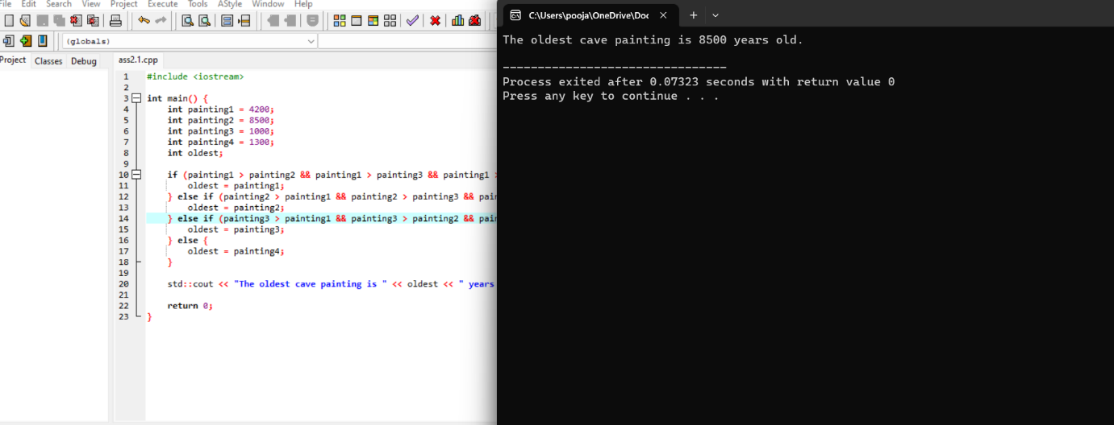

2.One bus Can carry 48 children. How many children can 3 buses carry write C++ program using parameterised constructor.

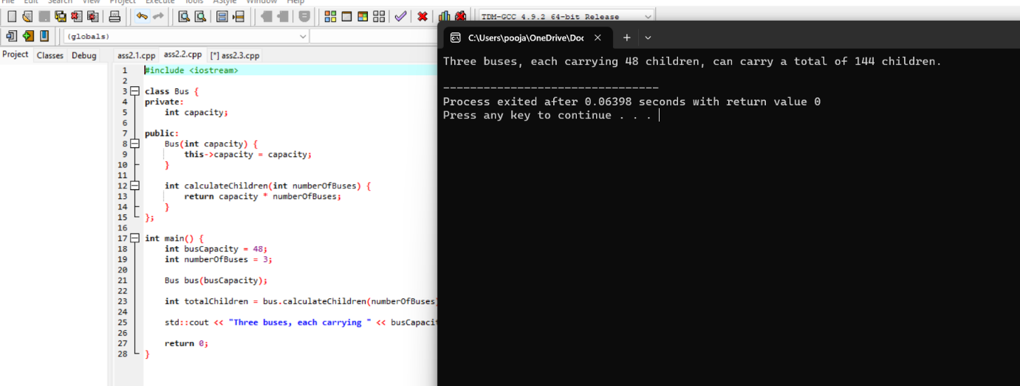

3. Kiran bought 1 kg plastic for $10, but sold 1 kg plastic for $12. How much money does she on selling 1 kg plastic? write a C++ program using Default constructor.

